ArchaeoFusion Software Evaluation
Part I: Objective 1. The case for using multiple Geophysical Methods
Claim: Multiple geophysical methods are usually better than one method alone, and ArchaeoFusion allows you to accomplish that more easily because it can handle all of the major data types (GPR, magnetometry, resistivity, and EM). The goal of this part is to simply show that multiple datasets provide more information that single datasets, even if they are not integrated together for the interpretation.
What you need:
- Processed Los Adaes Data. I have chosen only one 20 x 20 m survey tile so you don’t have to spend too much time on this.
- Site Background information: Los Adaes is a Spanish military post, mission, and settlement located in northwest Louisiana. It was chosen as the demonstration site for this ESTCP project, and was the site of the 2009 National Park Service Archaeological Prospection Workshop. See Appendix A for details.
Deliverables:
- For each survey (Resistivity, Conductivity, Magnetic Susceptibility, Magnetometry, and Ground-penetrating radar slice 5, 16-20 ns), identify and number all anomalies using outlines or lines. Report which anomalies are interpreted to be cultural features and which are probably not cultural features. Give the final count of (a) all anomalies, (b) cultural feature anomalies, and (c) non-feature anomalies.
- Using ArchaeoFusion, examine each anomaly previously identified and report whether the anomaly occurs in other datasets, and if so which ones. A table such as the following is suggested (one for each datasets). The “total” column gives the total number of other datasets in which the same or similar anomaly was found.
Resistivity Anomalies
Anomaly # | feature? | in mag? | in MS? | in Cond? | in GPR | total
1 | Y |  |  | x | x | 2
2 | N |  |  |  |  | 0
3 | Y | x |  |  |  | 1

Instructions:
A. Interpretation of non-integrated geophysical datasets
This part is to be done without ArchaeoFusion. The point is that you will have to examine each one separately without the advantage of overlay and integration offered in ArchaeoFusion. It is ok if the software you use allows you to overlay the surveys, but please don’t spend much time comparing the data. The point is to look at them separately for this part.
- Download the five surveys (png images) OR use the versions pasted in this document (below). These surveys were processed in ArchaeoFusion and exported. Each is 20 x 20 m, with north up, and using a reverse gray colormap (black indicates positive anomalies). Here are the image files:
ftp://ftp.cast.uark.edu/outgoing/eernenw/AF_eval/conductivity.png
ftp://ftp.cast.uark.edu/outgoing/eernenw/AF_eval/GPR16-20ns.png
ftp://ftp.cast.uark.edu/outgoing/eernenw/AF_eval/mag.png
ftp://ftp.cast.uark.edu/outgoing/eernenw/AF_eval/MS.png
ftp://ftp.cast.uark.edu/outgoing/eernenw/AF_eval/res.png
- Here are the surveys if you would rather copy and paste.
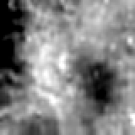Conductivity | GPR 16-20 ns | 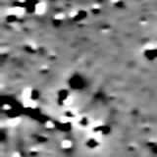magnetometry
Magnetic Susceptibility | 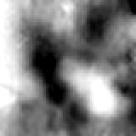resistivity

- For each separate data type (magnetometry, resistivity, conductivity, magnetic susceptibility, and one GPR slice (16-20 ns)) do the following:
  - Examine the image and identify ALL anomalies (even ones you don’t think are cultural features) above noise level.
  - Using your software of choice (Surfer, Photoshop, ArcMap, PowerPoint, etc), vectorize (outline) or otherwise mark and number each one.
  - Examine each anomaly and judge whether it is a feature anomaly (an anomaly that you think is likely to be an archaeological feature) or not based on anomaly amplitude, contrast, size, shape, relative location, and any other characteristics you can discern. DO NOT, however, use other datasets as comparison (i.e. do not check to see if the anomaly shows up in other datasets. We will do that in the next part).
  - Paste the image of each dataset with the anomalies marked and numbered into a document.
  - Make a list to show which anomalies are interpreted to be feature anomalies and which are not. State the total number of anomalies, and the total number of feature and non-feature anomalies. You could use a table such as the one suggested in the deliverables section above.
B. Examination and comparison of anomalies in ArchaeoFusion.
- Download the ArchaeoFusion project “LosAdaesProjectN610E470”.
ftp://ftp.cast.uark.edu/outgoing/eernenw/AF_eval/LosAdaesProjectN610E470.zip
The project is a folder with several subfolders and files. When you unzip, do not accept the default to place the zipped contents into a new folder entitled LosAdaesProjectN610E470. When you unzip the files they will already be in a directory by this name and creating another parent directory will mean that you will have to go in a level deeper to open the project directory from ArchaeoFusion. It will work that way, but can get confusing.
- Launch ArchaeoFusion and open the project.
Go to FileOpen Project, and then browse to the Project folder titled “LosAdaesProjectN610E470”. DO NOT double click on the folder to select it. Simply select the project folder with one click and then click the select button. Leave the check box checked to “let this project reset the coordinate system preference” and click Finish.
- Each of the five datasets is listed in the left column. For this exercise you will use the check boxes to turn the surveys (layers) on and off so you can see each one (surveys are on top of one another like in a GIS, and the survey listed at the top of the list is at the bottom of the pile in the viewing window, behind the others).
- You may also want to adjust the contrast for individual surveys. To do so you can either drag the slider bars, or right-click on the triangles at each end and enter a value (in standard deviations), then press enter. To change the color display you can turn the red, green and blue bands on and off using the radio buttons, or, you can change the colormap using the drop-down menu located in the right panel of the software window. You can ignore the EM38 survey, since it has been broken apart into separate conductivity and MS surveys. We are only using one GPR slice (16-20 ns) for this part.
- To pan around and zoom in and out, you can use a 3 button mouse, or the four buttons in the upper-right corner of the main viewing window. The main (left) mouse button shows you values for each pixel (see below). Use the wheel to zoom in and out (D=Dolly), and hold down the wheel or center mouse button and drag to move the survey around (P=Pan). Right click to change the viewing angle (R = Rotate). After messing with the last one you can go back to a flat, north-up view by right-clicking on the survey name in the survey list (left) and selecting “go to survey.”
- You may also want to explore the values for a survey and survey coordinates. To do so, highlight the survey in the survey list (white in the list on the left) and place the mouse over that spot and hold down the mouse button (left click). The top line gives you the values for that location (multiple values if there are multiple bands, as with GPR and EM). The middle line gives you the survey coordinates. The bottom line gives real world coordinates, but for this case we are not using them so the lower-left corner is given the false coordinates of 0,0 latitude, longitude.
- Now check each anomaly in each survey against the other surveys, and determine which anomalies are also found in other surveys. For each anomaly in each survey, report which other surveys it also occurs in, and then the total number of other surveys in which it occurs. A table such as that given in the deliverables section above would work well for this, and will make the evaluations much easier to compare and summarize.

Part II: Objectives 2-3. The case for Data Integration
Claim: Integration of multiple geophysical datasets improves potential for detecting archaeological features when compared to non-integrated data, and ArchaeoFusion makes this possible and efficient.
What you need:
- Same as above (LosAdaesProjectN610E470)
Deliverables:
- Use ArchaeoFusion to integrate or fuse some of the Los Adaes datasets and save the results as images (you will learn to use PCA, the Band Calculator, and transparencies).
- Answer two multiple choice questions about your experience.
Instructions:

A. Principle Components Analysis (PCA) of GPR slices.
It is often the case that each GPR slice contains different parts of the same anomaly, but if slices are made too thick other anomalies are not visible. It is sometimes desirable to summarize all of the information from several slices into one image. In consolidating all the slices into one you lose depth information, but this can be determined by comparing the fused slice image to the originals and to reflection profiles as needed. PCA is a useful technique for fusing different types of data too, but it works best with highly correlated images (as is often the case with GPR slices).
Principle components analysis (PCA) is a mathematic procedure that transforms a number of correlated input images into output images (“components”) that are uncorrelated. The first principal component usually accounts for most of the variability from all the input images, and each successive component summarizes less and less of the total variation. So if the input images are highly correlated (as is often the case with GPR slices), then the first principal component is often a very good summary of multiple slices. PCA also works well with different types of geophysical data.

- Open the Project “LosAdaesProjectN610E470”. NOTE: You should periodically save your project throughout this exercise to prevent losing work.
- Select (highlight) the GPR survey in the Survey List (left panel) and uncheck all the others.
- In the operation stack below (left panel, bottom), uncheck all of the operations.
- Click “run operation stack”. This will show you the original GPR slices. To look at each one separately, click the radio buttons next to the band numbers in the survey list. Notice that each slice contains similar information, but some of the anomalies are broken up into different slices. You can imagine that if added together they might be easier to interpret.
- Add a PCA operation by clicking on the button in the operations toolbar, or by selecting it from the Operations menu in the menu bar.
- Click “Run Operation Stack”
- Before looking at the results, take a look at the numerical results in the new matlab window (it may be behind your window – look for it in the taskbar). Expand the window so you can see all the text. It should look something like this:
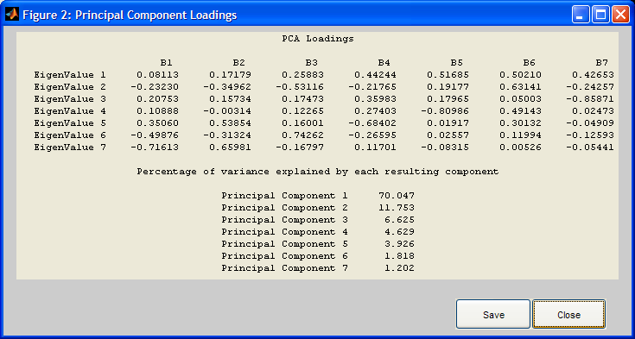
- Look at the bottom half of the window, where it says “Percentage of variance explained by each resulting component.” Principal component 1 explains 70% of the variance. This is good news and means that this may be the only slice needed to summarize all 7 of the originals. The remaining components may contain mostly noise and error, which is often more random.
- Close the PCA Loadings window (you can save if you want, but it is not necessary)
- Now look at the GPR survey. The bands (B1-B7) are now showing the principal components. Clearly the first one shows the main anomalies so we will save this to a new file and process it for interpretation later (note that you can do PCA on processed data, but I like to do it on the raw data because it is a good technique for noise reduction and so you can then process the result for a better final result).
- Click Tools Merge/Break Up Surveys. In the dialogue, check the box next to “Keep base layer resolution.” Enter a new Survey name: GPR PCA C1 (for GPR PCA Component 1). In the list of bands at the left, click on GPR B1. It will jump to the box at the right. This band will become Band 1 of the new survey. You could save the other components here as well, but we only need the first component. Click Finished. The new Survey is inserted at the bottom of the survey list.
- We can process this new survey using the same operations that worked well for the GPR slices. To do so, go back to the GPR survey (click on it in the list to highlight white). Make sure the new GPR PCA C1 survey is unchecked. Delete the PCA operation, check all the other operations, and click “run operation stack.” Next, click OperationsSave Operations… and save the operation stack. Give it a name, such as “GPRoperations” and save.
- Now we will load the GPR operations to the GPR PCA C1 survey. Highlight the GPR PCA C1 Survey and check the box so it is displayed. Go to OperationsLoad Operations… and browse to the “GPRoperations” file that you just created. Click open. The entire operations stack is now added to the survey.
- You can run all of the operations at once, or one operation at a time. Lets do one at a time so you can see what is being done.
- Check Resample, expand the operation (click the bar where it says “resample”) to see the input parameters, and run the operation stack. Resample changes the data density of a survey (you can increase or decrease the number of pixels). This is an important first step with GPR data because the original data contains hundreds of readings in the profile direction, but a reading every half meter in the other direction.
- Check Destagger, expand it, and run the operation stack. Destagger shifts every other row (or row pairs for special circumstances) to compensate for timing errors during data collection.
- Check ZMT, expand it, and run the operation stack. ZMT (Zero Mean Traverse) equalizes the mean, median, or mode of traverses. Often the median works best.
- Check Standardize, expand it, and run the operation stack. Standardize rescales the data on a scale of -1 to 1. Outliers are permitted, which is why the new standardized scale goes up past 20. This is not necessary since the PCA results are already standardized, but it was already in the operation stack and won’t harm anything. You can delete it if you like using the X to the right of the operation.
- Check Clip, expand it, and run the operation stack. This operation clips the data within the specified range, in this case -2 to 2, improving contrast.
- Check Resample, expand it, and run the operation stack. This is done a second time now that the data are processed, in preparation for smoothing. You see no change because the resolution in the x direction has only been doubled, and a nearest neighbor operation is used to duplicate pixels.
- Check Spatial Filter, expand it, and run the operation stack. Spatial Filter gives you the option of running high or low pass filters on the data. The disk filter does a nice job of smoothing out the data.
- Now you can save the result to an image file for one of your deliverables. Here are the instructions:
  - In the survey list on the left, highlight the survey you want to export (it will be highlighted white after you click on it). Make sure you are happy with the way the image looks (contrast and colormap look ok, etc.).
  - Tools Export Survey
  - Enter a file name
  - Choose by image size or pixel size. I suggest exporting by pixel size and entering 0.125 x 0.125.
  - Choose WYSIWYG (What You See Is What You Get) so that the exported image appears as it does on the screen.
  - Image Format: PNG is best for this situation, since we don’t care about geographic coordinates. It can be opened by almost any program, and even goes directly into ArcMap.
  - Click Finish. Image will show up in the main Project directory “LosAdaesProjectN610E470”

B. Translucent Overlays.
ArchaeoFusion has several options for viewing multiple datasets on top of one another as translucencies. This allows you to see several layers at once, up to a limit of course (at some point you simply can’t see through too many layers).

Instructions:

- Open the same project (LosAdaesProjectN610E470) if it is not already open.
- Look at all the surveys and to decide which ones you want to overlay. Let’s try MS and mag first, to see how they compare to one another.
- Using the small arrows to the right of the check boxes, move the mag and MS surveys to the top of the survey list so they are easily found and next to each other. Put the MS survey at the very top, with mag directly below it.
- Now change the colormap (right panel, near the top) to regular grayscale (grades from black to white, so positive anomalies are white)
- Check the box to display the MS survey (uncheck all other surveys), and use the radio buttons to make it appear red. Notice that the positive anomalies are now bright red.
- Now check the mag survey so it appears on top in the viewing window. Select only the green radio button. The positive anomalies are now green.
- With both surveys checked (displayed), click on the plus signs to the left of the survey names. This makes each one transparent and blend with any other survey that are also transparent (also have the plus sign changed to a minus).
- Now you can see that the anomalies in these two surveys are similar, but slightly offset! Positive MS anomalies are red, and positive mag anomalies are green, and where they overlap appears yellow. Why are they offset? This is not the subject of this software evaluation, but an interesting finding nonetheless. My hypothesis is this: I think the mag data are spot on, but the MS data (and conductivity, because both are collected with the EM38B) are about one meter too far north. This can easily be explained by positional error with the EM38, which happens to be 1 meter long (will have to check the data source to find out for sure).
- Now let’s add one more dataset: GPR PCA C1. Find this survey and move it up so it is directly under the mag survey in the survey list. Check the display box so we can see it (you have to uncheck the other two surveys also). Change its color to blue and notice that the positive anomalies, including what looks like the palisade anomaly, are now blue.
- Click the plus sign to make this survey transparent, and then check the MS and mag surveys so you can see all three at once.
- You can tell the anomalies from different sources apart by the colors, and you can also figure out which anomalies overlap by the color. According to the RGB color model, magenta means blue (GPR) and red (MS) are overlapping, yellow means red (MS) and green (mag) are overlapping, and…you get the idea (see color model below). If all three overlap you get white. You could do the same thing using the reverse gray colormap to see how the negative anomalies combine, if you wanted.
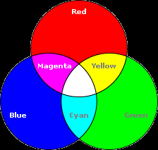
- Again we have anomalies that do not line up. The GPR anomaly for the palisade is way off. I think it is actually showing the location of the reconstructed palisade, which was removed prior to the survey, but which left marks on the surface. I will have to check the profiles, however, because the slices show that the palisade anomaly shows in the deeper slices only. Could be multiples that got magnified with depth by gaining the signal. But I digress…
- So, this is a quick and easy way to view multiple datasets. Since it is for display only and involves multiple surveys, it cannot be exported as one image. You should save the project, and print screen to paste into your report. We will actually recreate this using bands in a single survey in the next part so you can export it as an image. This is just a fast and easy way to use these tools to help interpret the data.

C. Mathematical Fusion Using the Band Calculator.
The Band Calculator is a tool that works as an operation in the operation stack. Using this tool, you can perform most mathematical operations on multiple bands of data. For this evaluation we will put several of our surveys into one survey (as separate bands) and then combine them by adding them together. You can also experiment with the max function (enter B6 = max(B1,B2,B3,B4,B5)), and using the reclassify operation to create binary or ranked images and then adding them together. But there is not enough time to do this here.

Instructions
- Open the same project (LosAdaesProjectN610E470) if it is not already open. Change the minus signs back to plusses from the previous section, and uncheck these surveys so they are not displayed. If you have continued working from the previous part, make sure to save the project.
- Now that we know that the EM (MS and Conductivity) data need to be shifted south, we can correct this problem before combining all the datasets. Here is what to do:
  - Find the MS Survey and make sure it is highlighted white in the survey list
  - Click the “Edit Survey” button on the shortcut bar (it is located directly under the Operations menu), or you can go to File Edit Survey.
  - This opens the Survey Tool, where we will nudge the survey south.
  - Find the snap size box along the top, toward the right. Change it to 1 and you will see the grid lines change so they are now spaced 1 unit (meter in this case) apart.
  - Normally you would have to select the tile you want to move, but in this case it is already selected since it is the only tile in the survey.
  - Now you can use the arrow keys located at the bottom right to nudge the tile once to the south (down). It will move according to the snap size. Alternatively, you can move it with the mouse, but nudging is easier for small distances.
  - Click finished. You will have to rerun the operation stack on the “new” survey, so click “Run Operation Stack” and be patient while it reruns all the operations.
  - Now you can display the MS as red and the mag as green and click the plus signs to see how they line up (remember to change the colormap to regular grayscale, black to white) (you don’t need to display the GPR for this). Much better! Where the two line up is yellow! Would probably work even better if the mag data were not dipolar!
- Now do the same exact thing for the conductivity survey.
- Create a new survey with each processed geophysical survey as one band:
  - Click ToolsMerge/Break Up Surveys
  - Uncheck the box next to “keep base layer resolution.”
  - Select “Set Pixel Size”
  - Enter .125 x .125 meters for the new x and y pixel sizes
  - Enter a new survey name: Math Fusion
  - Select the following bands from the left column, in this order: Conductivity B1, res B1, mag B1, MS B1, GPR PCA C1 B1 (we will use the fused GPR for this).
  - Click Finished
- Now we will label the new bands so we don’t forget which one is which. Highlight the new survey in the survey list, right-click on it, and choose Edit Band Labels. Enter the names of each of the input surveys for B1-B5: Cond, res, mag, MS, GPR C1. (I KNOW – this should be done automatically – working on it..)
- Now we can recreate the red-green-blue (RGB) overlay and save it as an image, but it will be better now that we have fixed the MS survey. Simply use the radio buttons to make the mag green, MS red, and GPR blue, and change the colormap to regular grayscale – black to white. The result should look identical to what we created using the translucent buttons (plus-minus signs), except now the MS and Mag anomalies line up better.
- Save this as an image (name it RGB_ms-mag-gpr or something to that effect) for one of your deliverables. Here are the instructions again:
  - In the survey list on the left, highlight the survey you want to export (it will be highlighted white after you click on it). Make sure you are happy with the way the image looks (contrast and colormap look ok, etc.).
  - Tools Export Survey
  - Enter a file name
  - Choose by image size or pixel size. I suggest exporting by pixel size and entering 0.125 x 0.125.
  - Choose WYSIWYG (What You See Is What You Get) so that the exported image appears as it does on the screen.
  - Image Format: PNG is best for this situation, since we don’t care about geographic coordinates. It can be opened by almost any program, and even goes directly into ArcMap.
  - Click Finish. Image will show up in the main Project directory “LosAdaesProjectN610E470”
- Now we are ready to use the band calculator. First, you will add a blank band so you have a place to save the new result. Click Tools add a band. A blank band is added to the bottom of the survey band list.
- Next, we need to get all the different data types on the same scale. To do this, add the Standardize Operation (from the Operations menu or the shortcut button along the top), and accept the default “by survey” mode, and click “Run Operation Stack”. Here is a little info about this (skip if you are in a hurry): Before this operation the data were in their native units (nanotesla, ohms, etc.) and had very different ranges (you can check the histogram in the lower part of the right panel (click the standardize operation in the stack to open it, which show the data before that operation is run, if you want to compare the histograms before and after). The top histogram is for the whole survey, and you can scroll through the five datasets (bands) using the arrow keys. The min and max values are given below each histogram, and the mean and standard deviation below that. Standardize simply transforms the histogram so that the mean is zero and the standard deviation is 1, to make data more comparable. If you select “by survey” then it treats the entire survey (usually made up of multiple tiles or “grids”) as one for the standardization. If you choose “by tile” then each tile is standardized (kind of like “zero mean grid” in Geoplot, if you are familiar, except the standardize operation also equalizes the standard deviations).
- Add a Calculator Operation by clicking the button in the shortcut menu bar along the top, or choosing it from the Operations menu. Write a function to add all of the bands together
  - Leave the radio button selection to “all”
  - For the left side of “=”, select B6 (this is the blank band, where the result will be written)
  - For the right side of “=” enter “B1+B2+B3+B4+B5” (you can type it in, or use the band buttons and plus button.
  - Run the Operation Stack
  - The result (Band 6) nicely shows most of the major anomalies from all the data. There are still a few problems with it though. Mainly, the magnetometry data have dipolar anomalies, and these mess up the math. This is why there is a gap in the palisade anomaly near the south edge of the survey area. You can look at the mag data and see why. Also, the conductivity and res data are basically the inverse of each other, and so they are mostly cancelling each other out. You could fix these problems by taking the absolute value of the magnetometry data, and by inverting the res data (both could be done with the band calculator), but for now we will keep this simple and stop here.
  - To simplify the result, let’s just omit the conductivity and res data. Click on the calculator bar in the operation stack to open the operation. Now delete the B1+B2 part of the expression so that it reads B6 = B3+B4+B5. Run the operation stack again.
  - Right click on the Math Fusion Survey in the Survey List and click Edit Band Labels. Name Band 6 “Sum3-5”
- Save the project and then save the “Sum3-5” band as an image (follow instructions given in step 7 above).

D. Multiple Choice Questions
Please answer the following two multiple choice questions with reference to your experience from the exercises above (PCA of GPR slices, translucent overlays, and mathematical sum).

1) Integrating multiple datasets using ArchaeoMapper increased my ability to detect feature anomalies.
a Very true
b Somewhat true
c Neither true nor false
d Somewhat false
e Very false

2) Integrating multiple datasets using ArchaeoMapper increased my ability to determine one or more characteristics of the feature anomalies (e.g., feature size, shape, depth, relative location to other anomalies, whether it was burned, presence of rock concentrations, etc.).
a Very true
b Somewhat true
c Neither true nor false
d Somewhat false
e Very false

Part III: Objectives 5 & 7: The case for ArchaeoFusion
Claim: (A) Data from the main types of geophysical sensors (magnetometry, resistivity, GPR, and EM) can be adequately processed and integrated using only ArchaeoFusion (no other software is needed); (B) these results can be achieved more quickly with ArchaeoFusion than with other commercially available software packages; (C) ArchaeoFusion records metadata more accurately and completely than comparable software.
What you need:
- Original data files for four adjacent tiles (“grids”) of data from four different types of instruments from Los Adaes.
  - GPR: GSSI SIR-3000
  - EM: EM38B & EM38MK2
  - Magnetometry: Bartington Grad601-2
  - Resistivity: Geoscan RM-15
- Instructions and guidelines given below.
Deliverables (it will help to read through all of these to see where it is going and plan how you will do things):
- Time required to process and integrate at least two of the Los Adaes datasets in your software of choice (whatever you normally use, not ArchaeoFusion). If you have experience with GPR and/or EM then we need you to choose these since this is the biggest strength of ArchaeoFusion. If you are only familiar with one method then that is ok, but try to use a second if you can. It would be best to get a detailed time log from you for each step of the way – e. g. how long it took to import and assemble the EM data, then to process it, then to preprocess the GPR data, slice it, assemble slices, process them, then integrate both together. If you do not know how to integrate multiple datasets then just state that this part could not be completed given your experience or limits to software.
- Instructions for another person to replicate what you did. Think of this as creating an archive, which should contain raw data, finished results and a description of how the results were achieved. It is up to you how you want to do this. You might decide that you want to avoid being software-specific, or you could provide directions requiring a certain software. This is one of the challenges of creating a data archive. This can also be time consuming and so you should be realistic about how much detail you are able to provide given your time constraints. It could range from a copy of hand-written notes to a more formally written document. If your archive does not contain all of the details required for someone else to reproduce what you did then this is simply a reality and helps identify where geophysics software needs improvement.
- Time required for you to replicate another person’s results by following their directions (please complete the other deliverables and you will be notified when there are instructions from someone else for this part.)
- Time required for you to process and integrate the provided Los Adaes datasets using ArchaeoFusion. Again, try to provide a detailed time log like the one for your work in other software. Step-by-step instructions for this are provided below.
- Instructions for another person to replicate what you did using ArchaeoFusion. Just as for #2 above, think of this as an archive with raw data, final results, and a description of how the results were achieved. This could look something like what is provided for you in the instructions below. ArchaeoFusion will eventually have an export function for creating an archive (will include raw data, results, and all processing steps), but it will not be ready for the first version. In the mean time, you can get data processing information for each survey by opening the “survey.operationlist” file in wordpad. This file is located in the project folder under surveys, and then the name of the survey. For example, for the res data used in the first project the file is here: LosAdaesProjectN610E470\Surveys\res\survey.operationlist. You can also save the operation stack and include it in the archive.
- Time required for you to replicate another person’s results by following their directions and using ArchaeoFusion (again, you will be notified when directions are ready for you. First complete the other deliverables and submit them, so your instructions can be used by another participant).
*deliverables 3 and 6 cannot be done until we get deliverables 2 and 5 from other participants and send to you. Please complete 1, 2, 4, and 5 and send to us as soon as you can so we can send them to other participants to complete 3 and 6.
Instructions:

In this exercise we are testing the capability of ArchaeoFusion compared to other software. Since you are new to ArchaeoFusion and the user’s manual is not yet complete, the instructions below will walk you through some of the steps required, but in other parts the guidelines are more general and you will have to make some decisions about the parameters for processing based on your own expertise. You only need to process the types of data that you are familiar with, although you can do the others if you wish. PLEASE EMAIL EILEEN AS SOON AS YOU HAVE DECIDED WHICH DATASETS YOU PLAN TO USE FOR THIS PART.

A. Creating a New Project .

- Download and unzip the data from the following links (save in a directory that you will remember):
ftp://ftp.cast.uark.edu/outgoing/eernenw/AF_eval/EM.zip
ftp://ftp.cast.uark.edu/outgoing/eernenw/AF_eval/mag.zip
ftp://ftp.cast.uark.edu/outgoing/eernenw/AF_eval/res.zip
ftp://ftp.cast.uark.edu/outgoing/eernenw/AF_eval/GPR.zip
- Launch ArchaeoFusion and select FileNew Project
- Name the Project “LosAdaesProject”
- Browse to a location on your computer to save it. This could be the same place where you are storing the data. When you are in the chosen directory, click Select.
- Click Finish

B. Loading Magnetometry Data

- FileNew Survey. This opens the Survey Tool
- In the Survey Tool, Select File Add Tiles. This brings up the Load File dialogue
- Select the following parameters for the magnetometry data (the only thing you have to change from default is the Direction of First Traverse):
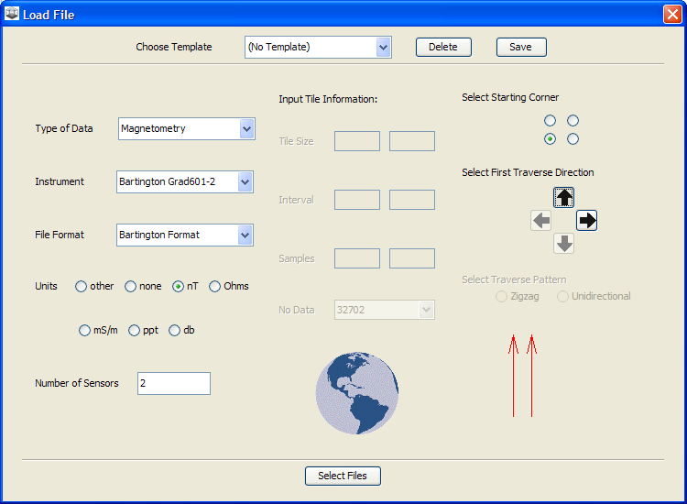
- Click Select Files
- Browse to the data files and select all the magnetometry files (all have “m” prefix). Click Select Tiles
- The tile names give the northing, followed by the easting. So you can arrange the tiles in the correct location using these coordinates. They should be arranged as follows:
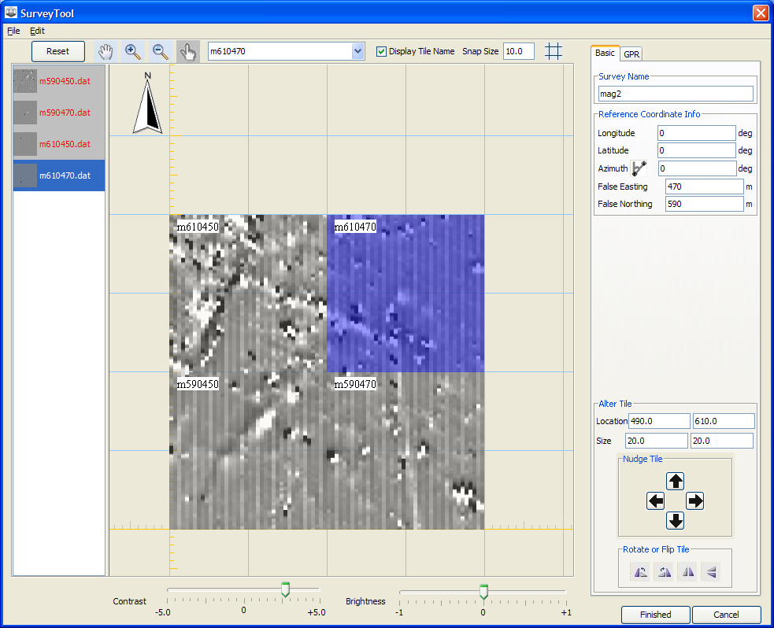
- Enter the name “mag2” in the “Survey Name” Field in the upper right. At this point you could enter real world coordinates such as UTM but for simplicity we will just enter 0, 0, 0 for the longitude, Latitude, and azimuth. Even though it says degrees it will not treat the data as such unless we enter actual coordinates. Since we are working in plane coordinates, we can enter a false easting and northing, which corresponds to the intersection of the orange lines in the gridding window. Enter False Easting 450, False Northing 590.
- Click Finished.
- Click FileSave Project

C. Loading the Resistivity Data

- FileNew Survey. This opens the Survey Tool
- In the Survey Tool, Select File Add Tiles. This brings up the Load File dialogue
- Select the following parameters for the resistivity data:
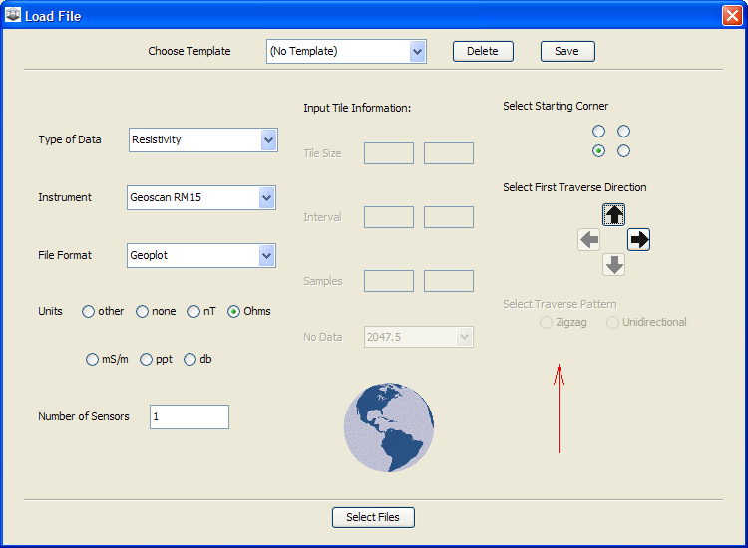
- Click Select Files
- Browse to the data files and select all the resistivity files (all have “R” prefix). Click Select Tiles
- The tile names give the 3-digit northing, followed by the easting. So you can arrange the tiles in the correct location using these coordinates. This is a glitch right now with this import parser, so if the tiles come in incorrectly rotated, use the rotate tool (lower right) to rotate each one counterclockwise once. You can easily tell that they line up much better after you rotate them. They should appear as follows:
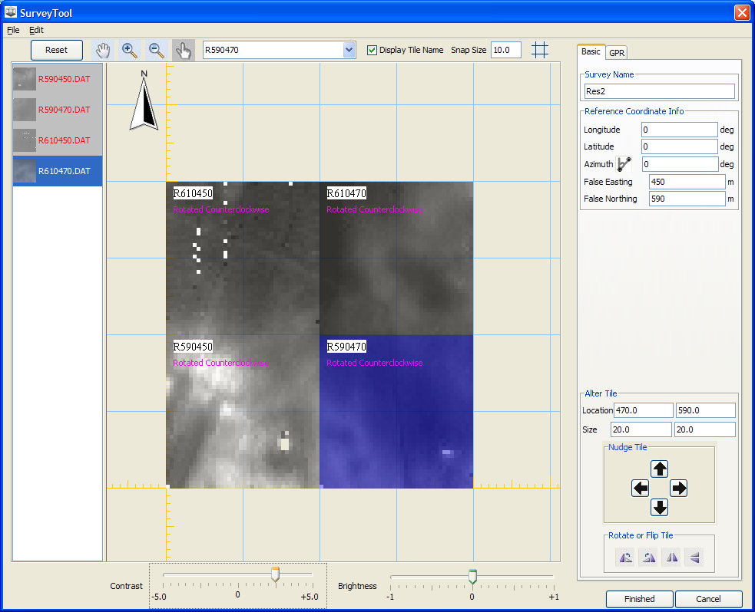
- Enter the name “res2” in the “Survey Name” Field in the upper right. Enter 0, 0, 0 for the longitude, Latitude, and azimuth. Enter False Easting 450, False Northing 590.
- Click Finished.
- Click FileSave Project.

D. Loading the EM Data

- FileNew Survey.
- In the Survey Tool, Select File Add Tiles. This brings up the Load File dialogue
- Select the following parameters for the EM38MK2 data:
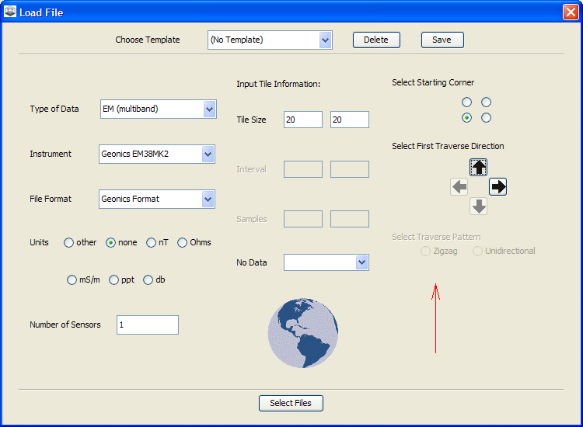
- Browse to the data files and select the EM38MK2 file (there is only one: n590e450.N38). Click Select Tiles
- This takes you to a window where you can edit the lines and individual readings if necessary.
- Each of these lines should have 100 readings (numbered 0-99), so extra readings at the end of each line need to be deleted. Expand the window or scroll over to the right. You can delete whole columns (up-down lines) by clicking on the column heading. In this case, you can click on 111.0, 110.0, 109.0, etc and they will be deleted. Delete all the columns beyond 99. There will be a few rows with missing readings at the end.
- Next, you will delete the extra rows at the top. Delete rows 40 and 41 by clicking on those numbers on either side of the row (rows go left to right). When you are done it should look like this:
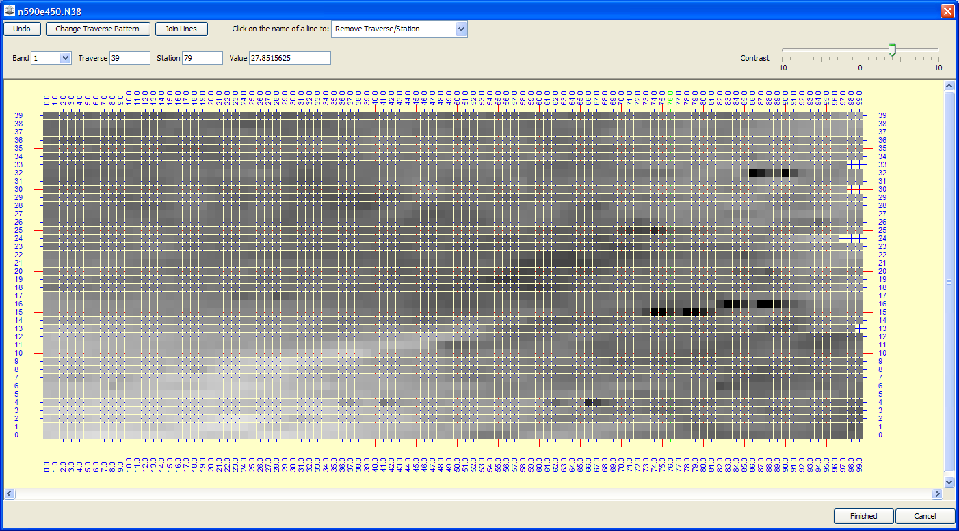
- Click Finished.
- Back in the Survey Tool, drag the tile into the gridding window and place it in the lower left corner.
- Now we will load the other 3 EM tiles, which were collected with the EM38. Click FileAdd Tiles
- Enter the following parameters in the Load File Dialogue:
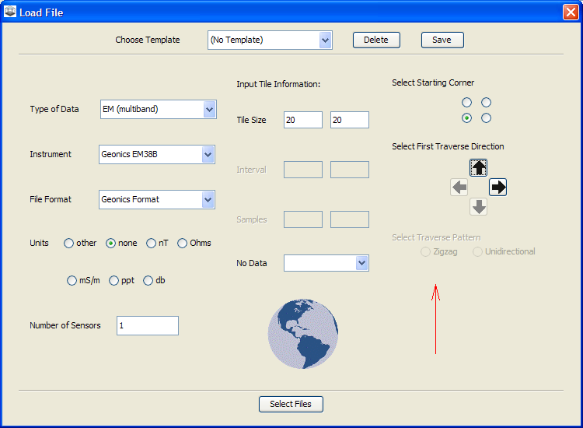
- Click Select Files
- Select the three EM38B files (the 3 files with the .B38 extension).
- Each of these tiles will open in the EM editing window, just like the EM38MK2 file did. All of the files are fine as they are (each has 40 columns and 40 rows) so for each one you can just click Finished.
- Drag these tiles to the gridding window and arrange according to the coordinates given in the file names. The file names give three digits for the northing and three digits for the easting. So file 590470 is at north 590, east 470.
- Enter the name “EM2” in the “Survey Name” Field in the upper right. Enter 0, 0, 0 for the longitude, Latitude, and azimuth. Enter False Easting = 450, False Northing = 590.
- The arrangement should look like this:
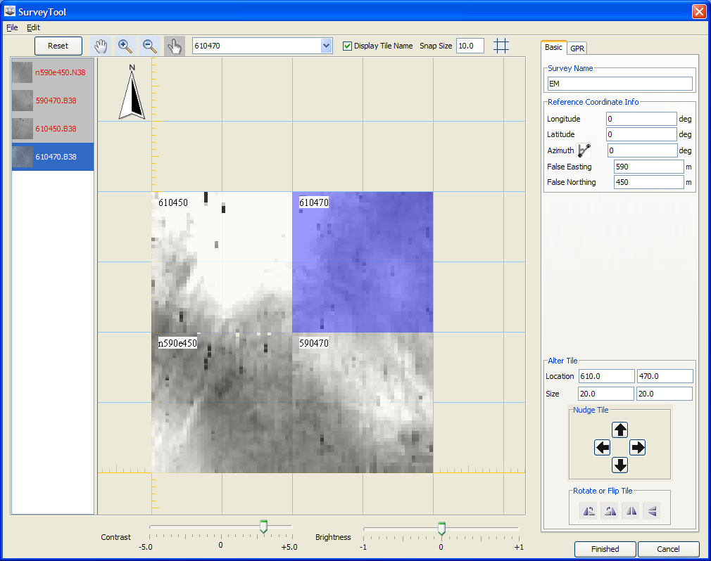
- Click Finished. This will take you back to the main ArchaeoFusion window
- Click FileSave Project to save the work you have done so far.
- The new EM Survey is shown in the Survey List. Click on it so that it is selected. This survey has four bands because the EM38MK2 tile in the lower-left corner has four different data sets, in the following order:
  - Band 1 = conductivity for the 1 m coil spacing
  - Band 2 = magnetic susceptibility for the 1 m coil spacing
  - Band 3 = conductivity for the 0.5 m coil spacing
  - Band 4 = magnetic susceptibility for the 1 m coil spacing
- If you click on the radio buttons to display the different bands, you will notice that bands 3 and 4 are blank for the three EM38B tiles. This is because the EM38B only collects data for the 1 m coil spacing. For this exercise we will only use the 1 m data. We will also create separate surveys for the MS and conductivity data, since they are so different and require different processing.
- Go to Tools Merge/Break Up Surveys
- Create a Conductivity survey named Cond2 by entering the following parameters:
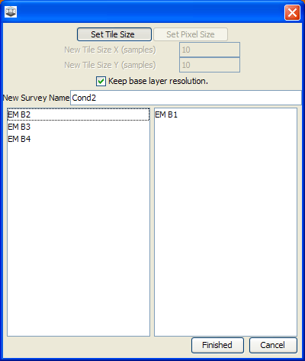
- Click Finished
- Follow the same procedure to create MS2 (for magnetic susceptibility) from EM B2. The dialogue should look like this:
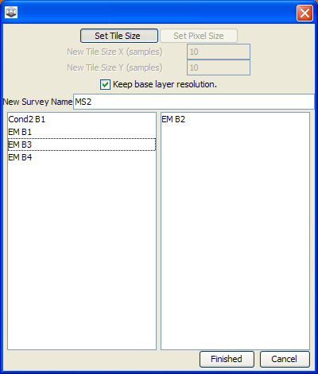
- Click Finished.
- Click FileSave Project.

E. Loading and Slicing the GPR Data.

- We will do only the minimum necessary for GPR profile processing here, for the sake of time. The GPR Loader is set up so that in many cases you can simply click next and default setting work, or you can skip steps.
- FileNew Survey. This opens the Survey Tool
- In the Survey Tool, Select File Add Tiles. This brings up the Load File dialogue
- This time you will save a template so that you can re-use it for each GPR tile, which is loaded separately.
- Select the following parameters for the GPR data:
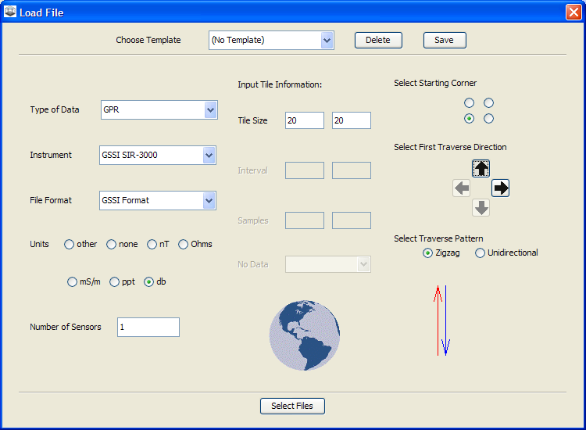
- Click Select Files
- Browse to GPR files that make up tile N590E450 (they are in a directory by that name). Click Select Tiles
- The GPR Reflection profiles will load one by one into the GPR Loader. Follow these steps as you go through the loader:
  - Enter a Tile Name: N590E450. Click the Next button in the upper-left
  - Bandpass Filter: First corner = 200 MHz, Second Corner = 800 MHz (there are high and low band pass filters). These should be automatically entered as defaults. Click Next
  - Fiduciary Mark Adjust: enter 2 for meters per mark. The columns on the left of this display give you the order of the files (1, 2, 3, etc), the start and end distances (start at 0, end at 20, for example), and then the number of marks. The rest of each line gives you the number of marks currently in each line. All full length profiles should have 11 marks. Those that do not are highlighted red. You can add and remove marks with the right mouse button, and slide them around with the left mouse button. If there are places where two marks are very close together or on top of each other, they are highlighted red. This editor is set up so you can figure out where the marks should be by looking at the data, without necessarily having field notes. I’m giving you the exact edits because you are just learning to use the software.
    - You will need to add marks at the beginning of lines 5, 6, 7, 12 (I suggest you right click a short distand away from the start of the line to add each mark, then drag it all the way to the left with the left mouse button).
    - Add marks at the end of lines11,16, 18, 25-29
    - Delete extra marks in lines 27-29 and 33. You can easily pick these out by the spacing or by red highlights showing you places where there are double marks. Right click on a mark to delete it.
    - Lines 30-32 are missing data.
    - Lines 30-32 are too short (instrument stopped recording for some reason), so you will have to edit the start and end points (column to the left of the mark counts). Lines 30 and 32 end at 12 meters. Line 31 starts at 16 (and ends at 20 meters).
    - If at some point you are worried that you messed things up and need to start over, just click reset marks.
  - Click Next
  - Auto Level: Check the box in the upper-right to skip this step, then click next.
  - Clip Soundings: Here you can clip off the top part of the signal so you can set time zero at the time that you think represents the ground surface. Click the mouse in the graph at the spot you want to use. You can click again and again to change the location, or hold the mouse buton down and drag the line. You could also right-click to clip off part of the signal at the bottom, but we won’t do that now. The graph should look something like this:
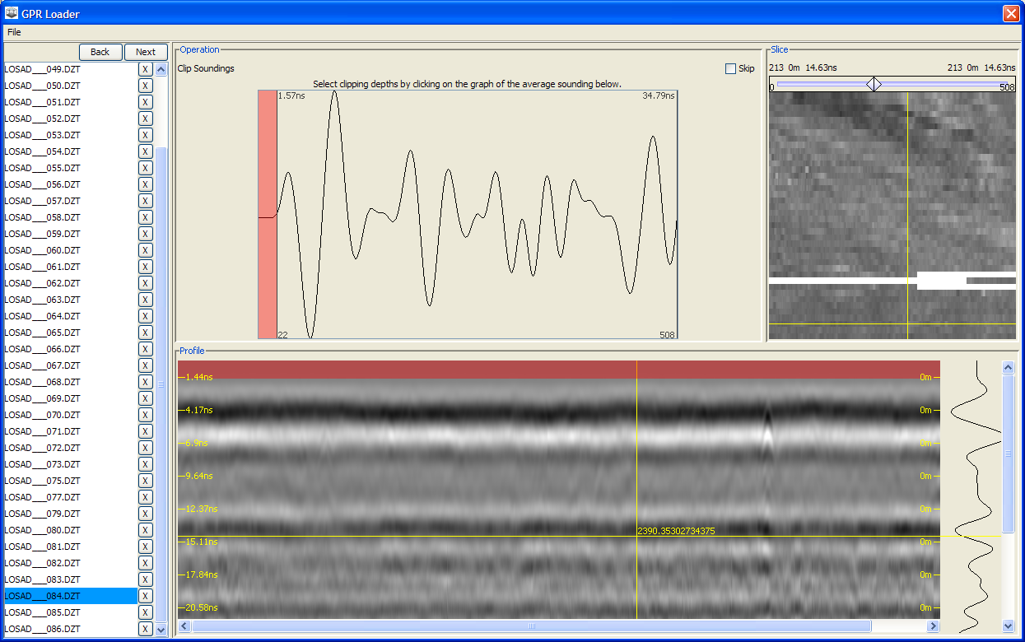
  - Click next
  - Remove Average Sounding (Background Removal). Click next to do this.
  - Gain adjust. In the interest of time, you can skip this step. Check the box next to skip in the upper-right and click next.
  - Depth Adjust: you can skip this too. Check the skip box and click next.
  - The input box comes up asking for a tile name. Since you already entered it at the beginning it will already be there (nice for those of us that are forgetful!). Just click ok. If you accidentally delete it, re-enter N590E450. After you click ok you will have to wait a few moments for the 3D cube to be created. It is creating a big file so may take a little while.
  - Click Done
- Now we want to add this tile to the new survey. Click and drag it over to its proper place.
- Enter the name “GPR” in the “Survey Name” Field in the upper right. Enter 0, 0, 0 for the longitude, Latitude, and azimuth. Enter False Easting 450, False Northing 590. Do not click finished yet (if you accidentally do, you can just click edit survey to get back here).
- Click on the GPR tab in the right panel of the Survey tool. This is where we can create GPR slices, which will become separate bands in the GPR survey.
  - Select “by ns” (by nanoseconds)
  - Change the slicing method to “sq” for squared amplitudes.
  - Click the auto button to generate a series of slices at equal intervals.
  - Enter from 0 ns to 28 ns; 7 slices, 4 ns thick
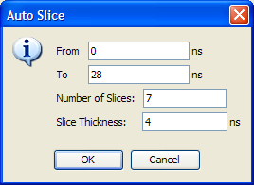
  - Be patient as slices are created.
  - Now you can click on the radio buttons next to the slices to view each one. Your window should look like this:
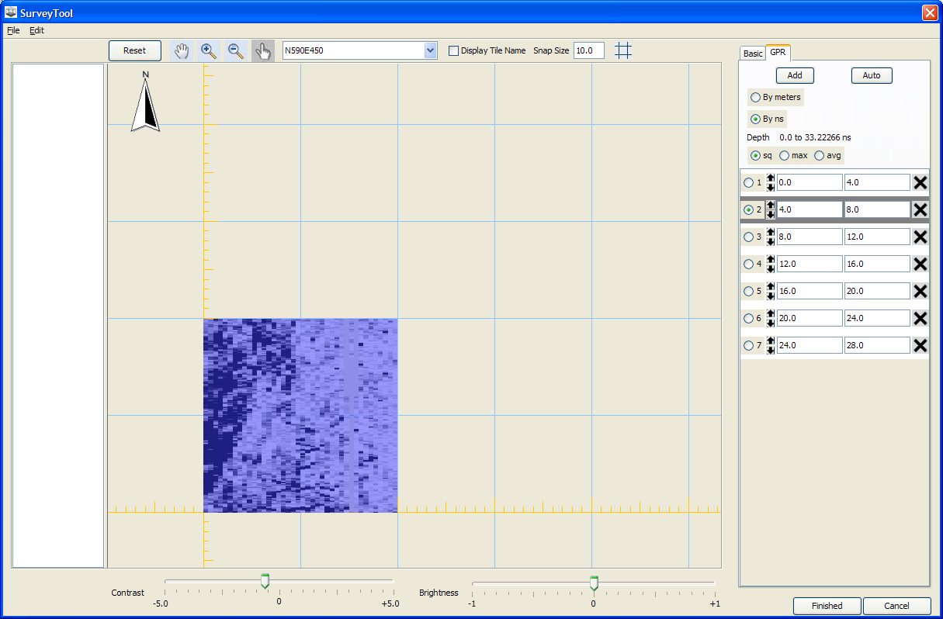
  - Click Finished
  - Click File Save Project
- Now we want to process the remaining 3 GPR tiles. They are similar to the first one, but were collected by someone else, this time using the 3D mode with the SIR3000. This means that we need to select different options in the load file dialogue and then do similar processing to three sets of profiles. Once we do the first, we can click restart and do the other two using the exact same parameters. We can even copy some of the parameters from the first GPR cube to get started
  - Make sure the GPR Survey is highlighted in the survey list. Click FileEdit Survey.
  - In the Survey Tool, Select File Add Tiles. This brings up the Load File dialogue
  - Select the following parameters for the GPR data (same as before but unidirectional survey):
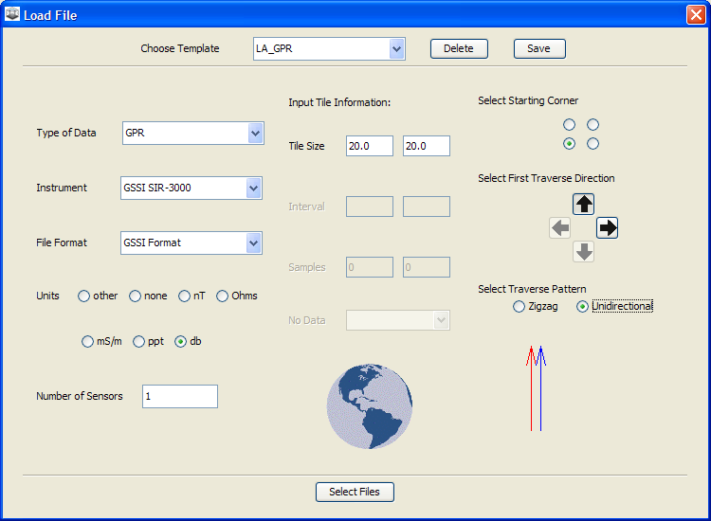
  - Click Select Files
  - Browse to GPR files that make up tile “Grid8_N590E470” (they are in a directory by that name). Select all 40 profiles and click Select Tiles
  - The GPR Reflection profiles will load one by one into the GPR Loader.
  - Follow these steps as you go through the loader:
    - Enter a Tile Name: N590E470.
    - Now click FileLoad Parameters and select the file N590E450.parameters (this will load the same parameters used for the last GPR file set). Click Open
    - You can now scroll through using these parameters, except you can handle the “Fiduciary Mark Adjust” part differently (much easier) and should double check the “Clip Soundings” setting.
    - When you get to “Fiduciary Mark Adjust” you can just click “clear marks” and then Next. This will just stretch out all the lines to the length specified in the load file dialogue (20 meters). They are already nearly perfect in length due to the way they were collected.
    - Don’t forget to adjust the time depth for time zero (“clip soundings”)
    - The input box comes up asking for a tile name. Since you already entered it at the beginning it will already be there (nice for those of us that are forgetful!). Just click ok. If you accidentally delete it, re-enter N590E470. After you click ok you will have to wait a few moments for the 3D cube to be created. It is creating a big file so may take a little while.
    - Don NOT click Done. It is easiest to just click Restart here (upper left). It saves the same parameters that you just used, plus the same file loader settings.
- Now we want to process the last two GPR tiles, starting from where you left off above. The other two tiles are “Grid9_N610E470”, and “Grid10_N610E450”. For each one:
  - Enter a Tile Name (corresponding to the file set you are processing).
  - Click the Load Profiles button, browse to the GPR profiles for the tile you are going to process, select them all, and click Open.
  - You can scroll through using the next button for every step, except you will have to click “clear marks” in the Fiduciary mark Adjust step. The time zero setting (“clip soundings”) should be fine for Grid9, but will need to be increased for Grid 10.
  - After the third GPR tile, remember to click Restart instead of Done.
  - After the last GPR tile, click Done
- Now we want to add these 3 tiles to the GPR survey. Click and drag them over. Each one will take a little while since it will be creating slices. When you are done it should look something like this:
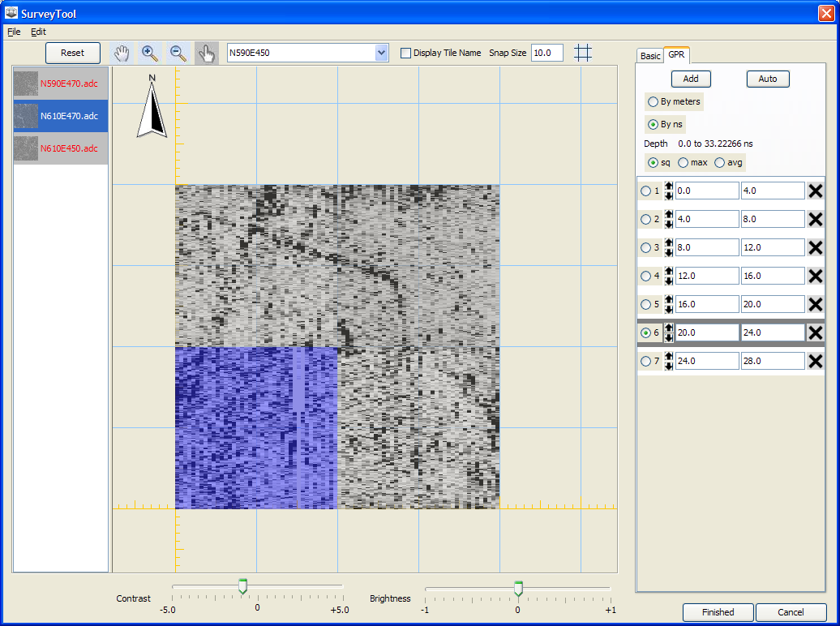
- Enter the name “GPR” in the “Survey Name” Field in the upper right. Enter 0, 0, 0 for the longitude, Latitude, and azimuth. Enter False Easting 450, False Northing 590. Do not click finished yet (if you accidentally do, you can just click edit survey to get back here).
- Click Finished
- Click File Save Project

F. Processing the Magnetometry Data

- The Magnetometry data are in need of the destriping, clipping, destaggering, and smoothing. You can follow this recipe (it is exactly the same as used in the previous project, LosAdaesN610E470), or change it based on your own preferences and expertise. You may want to consult the draft user’s manual to learn more about all the operations.
  - Zero mean traverse
  - Clip
  - Destagger
  - Resample
  - Spatial filter
  - Resample
  - Spatial Filter

G. Processing the Resistivity Data

- The Resistivity data are in need of the filling, despiking, edge matching (“Balance” is a way to automatically match edges that sometimes works), and smoothing. You can follow this recipe (it is exactly the same as used in the previous project, LosAdaesN610E470), or change it based on your own preferences and expertise. You may want to consult the draft user’s manual to learn more about all the operations.
  - Fill
  - Despike
  - Balance (automatic Edge or Range Matching)
  - Spatial Filter
  - Resample
  - Spatial Filter
  - Spatial Filter

H. Processing the Magnetic Susceptibility Data

- The MS data are in need of standardizing, despiking, detrending, range matching, and smoothing . You can follow this recipe (it is modified from the one used in the previous project, LosAdaesN610E470), or change it based on your own preferences and expertise. You may want to consult the draft user’s manual to learn more about all the operations.
  - Fill
  - Standardize (this equalizes differences between tiles, sort of like Geoplot’s “Zero Mean Grid”). The data from the two different EM38 instruments are on very different scales.
  - Despike (2 times)
  - Despike on the two western tiles (select the “Tiles” Radio button and then click on the two western tiles)
  - Detrend
  - Range Match of NW tile to NE tile
  - Range Match of SW tile to SE
  - Resample
  - Spatial Filter
  - Spatial Filter

I. Processing the Conductivity Data

- The Conductivity data are in need of the filling, despiking, and smoothing. You can follow this recipe (it is exactly the same as used in the previous project, LosAdaesN610E470), or change it based on your own preferences and expertise. You may want to consult the draft user’s manual to learn more about all the operations.
  - Fill
  - Despike
  - Despike
  - Spatial Filter
  - Resample
  - Spatial Filter

J. Processing the GPR Data

- We will combine the GPR slices again using PCA. This time we will need to prepare the data since it was collected by two different instruments and needs to be standardized. Here’s what to do:
  - Select (highlight) the GPR survey in the Survey List (left panel) and uncheck all the others.
  - Add a Standardize Operation, and select “by tile” (this equalizes the tiles statistically, and for each GPR slice)
  - Now add another Standardize operation, this time we need to run it by survey so that all the GPR slices (bands) are standardized.
  - Finally, we want to fill in the missing data in the SW tile. Add a Fill operation.
- Now add a PCA operation by clicking on the button in the operations toolbar, or by selecting it from the Operations menu in the menu bar.
- Click “Run Operation Stack”
- You can look at the results in the new matlab window. The percent of variance explained by component 1 is not as high as before, but looking at it still shows that it summarizes the data well, with some anomalies in component 2. We can just use component 1 for this exercise.
- Close the PCA Loadings window.
- Click Tools Merge/Break Up Surveys. In the dialogue, check the box next to “Keep base layer resolution.” Enter a new Survey name: GPR PCA C1 (for GPR PCA Component 1). In the list of bands at the left, click on GPR B1. It will jump to the box at the right. This band will become Band 1 of the new survey. Click Finished. The new Survey is inserted at the bottom of the survey list.
- The GPR PCA C1 data are in need of the resampling, destaggering, clipping, tile matching, and smoothing. You can follow this recipe (it is modified from the one used in the previous project, LosAdaesN610E470), or change it based on your own preferences and expertise. You may want to consult the draft user’s manual to learn more about all the operations.
  - Resample
  - Destagger
  - Standardize
  - Clip
  - Balance
  - Range Match SE Tile to SW tile
  - Resample
  - Spatial Filter

K. Integrate the Geophysical Data

- Using the techniques you learned Part II (beginning on page 4), integrate the geophysical data that you have processed. You can do exactly the same thing that was done in Part II, or try other methods.

L. Finish Deliverables

- Export images (see instructions in Part I) or use print screen to show the results of your processing for each dataset (that you chose to do) and for your final fusion result
- Report the time it took to process each dataset, and the time it took to integrate the results into at least one combined image.
- Report

